SMART INDIA HACKATHON 2026
Hybrid Quantum Machine Learning Platform
for Early Disease Detection
SIH26139 | MedTech / BioTech / HealthTech | Software
Team: C0mmit & Conquer
Technical & Research Report
A practical, simulator-based hybrid ML/QML approach for early disease-risk assessment, benchmarking, explainability and uncertainty-aware decision support.

Contents

1. Executive Snapshot
2. Why This Problem
3. Proposed Solution
4. System Architecture
5. Workflow A: Multimodal Evidence
6. Workflow B: Classical vs Quantum Benchmark
7. Workflow C: Practical QNN Pipeline
8. Uncertainty and Human Review
9. Innovation and Uniqueness
10. Technical Stack
11. Experimental Plan
12. Feasibility, Risks and Mitigation
13. Safety, Ethics and Indian Regulatory Boundary
14. Implementation Roadmap
15. Expected Impact
16. Limitations and Future Scope
17. Additional Features
18. References

1.Executive Snapshot

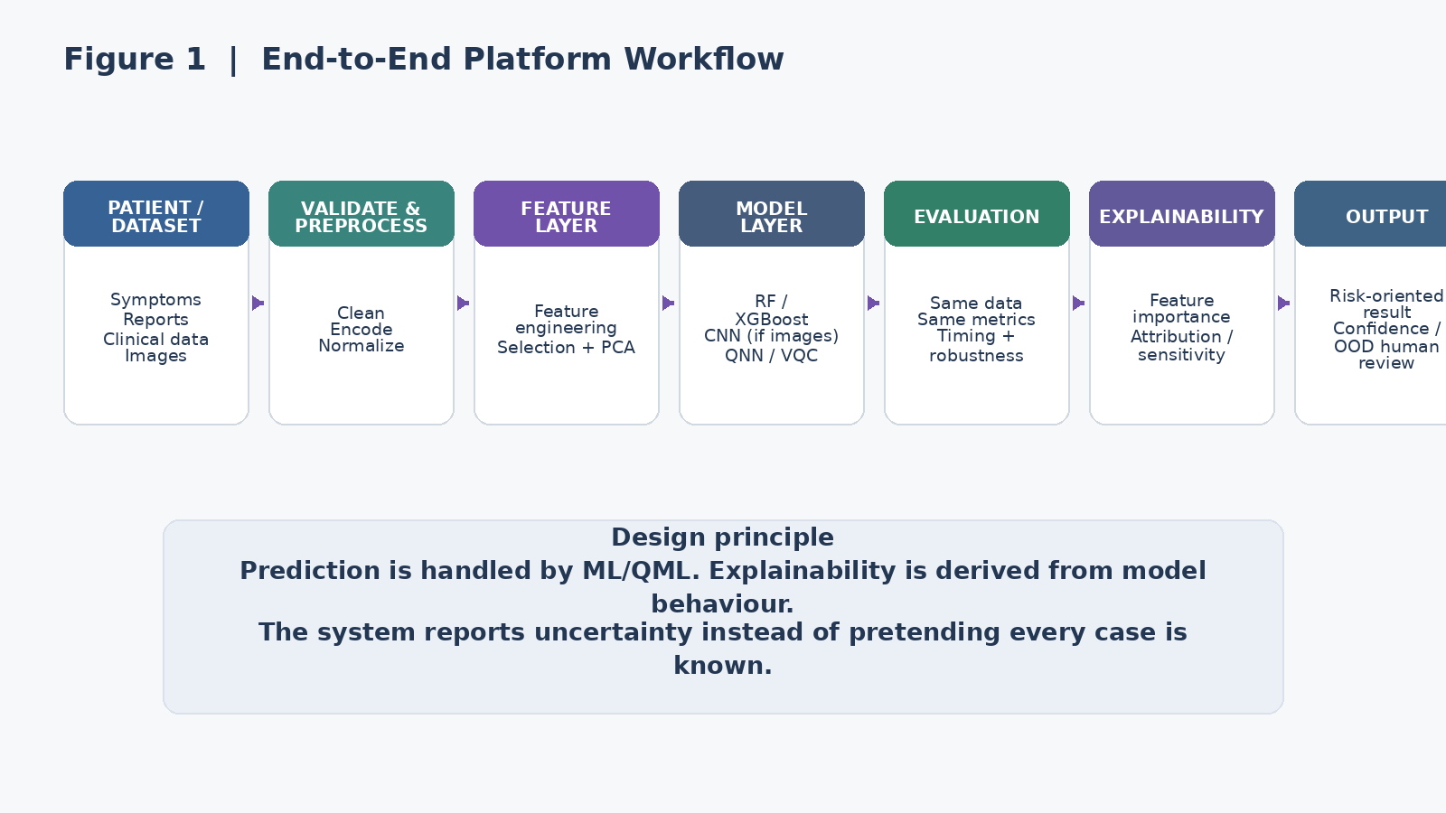
Figure 1. The report follows the same core flow shown in the submitted PPT, expanded into a working research workflow.

The project is built around one question: can a hybrid quantum-classical workflow provide measurable value for early disease-risk assessment on a defined biomedical task? The answer is not assumed in advance.
- Classical models create strong baselines instead of a weak comparison target.
- A compact QNN/VQC experiment tests the quantum path after feature selection and dimensionality reduction.
- A CNN is used only when image data is relevant to the selected task.
- The model outputs stay within the ML/QML layer; explainability and uncertainty are handled directly from model behaviour and controlled evaluation.
- Confidence/OOD checks are used to avoid forcing a prediction when the system is uncertain or unfamiliar with the input.
This is deliberately narrower than a “do everything” healthcare platform. A judge should be able to trace one patient or benchmark record from input to model, from model to evidence, and from evidence to a clearly bounded next step.

2. Why This Problem
The SIH26139 statement describes early disease detection as a difficult problem because biomedical data can be high-dimensional, noisy and complex. It specifically asks for classical preprocessing and feature engineering followed by quantum-enhanced learning, data ingestion, hybrid training, prediction, explainability and comparison with classical baselines. These requirements are reflected directly in the submitted PPT, especially the “Proposed Solution & Problem Addressed” and “Technical Approach” slides. (submitted PPT, slide 2)
Our design stays focused on the SIH requirement: hybrid classical-quantum learning, explainability and benchmarking.
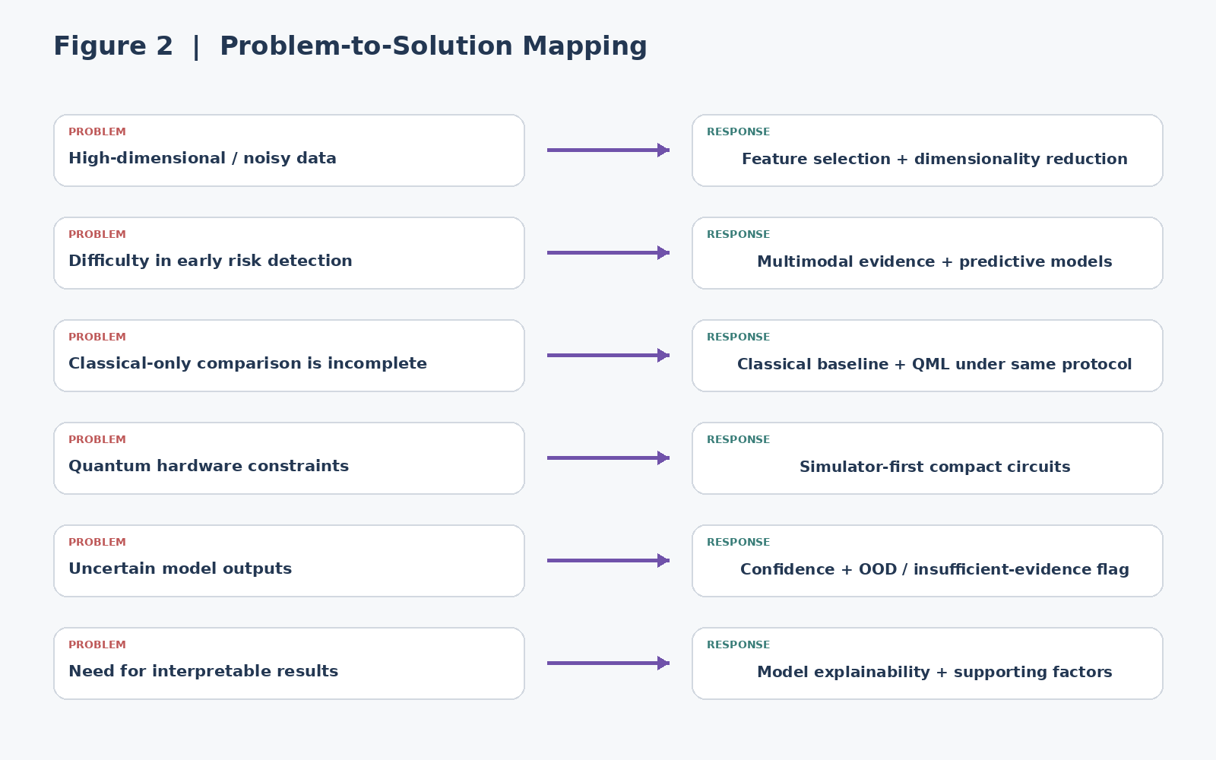
Figure 2. Each major problem in the SIH statement is paired with a concrete engineering response.

3.Proposed Solution
The solution is a multimodal disease-risk assessment platform. It accepts the evidence available for the chosen benchmark task, validates and compresses it, evaluates classical and quantum models, and presents the result with model explainability and uncertainty visible.
- Symptoms / structured clinical fields are validated and transformed into model-ready features.
- Reports can contribute structured fields or extracted information, subject to the chosen dataset and permitted processing.
- Medical images are handled through a CNN only when the selected disease task includes images.
- Random Forest and XGBoost act as strong classical references.
- QNN/VQC is evaluated on a compact feature representation using a simulator. QSVM remains a secondary option when a fair experiment is practical.
- Model explainability links the prediction to the most influential or relevant input features, with confidence and uncertainty shown alongside the result.
- The final result includes a risk-oriented output, supporting model factors, confidence/uncertainty and a human-review message where required.
The intended output is not “you have disease X.” The intended output is a research-oriented risk signal with supporting model factors and a clear boundary around what the model does not know.

4. System Architecture

Figure 1. End-to-end platform architecture.

Layer | Technology | Purpose
Frontend | React.js / React Native | Simple patient/researcher interface
Backend | Python + FastAPI | Orchestration and APIs
Classical ML | Scikit-learn + XGBoost | Baselines and structured-data models
Deep Learning | PyTorch | CNN when image evidence is part of the task
Quantum ML | PennyLane + Qiskit simulators | QNN/VQC experimentation
Database | PostgreSQL | Controlled storage of application data / experiment metadata
Deployment | Docker | Reproducible services

5. Workflow A: Multimodal Evidence
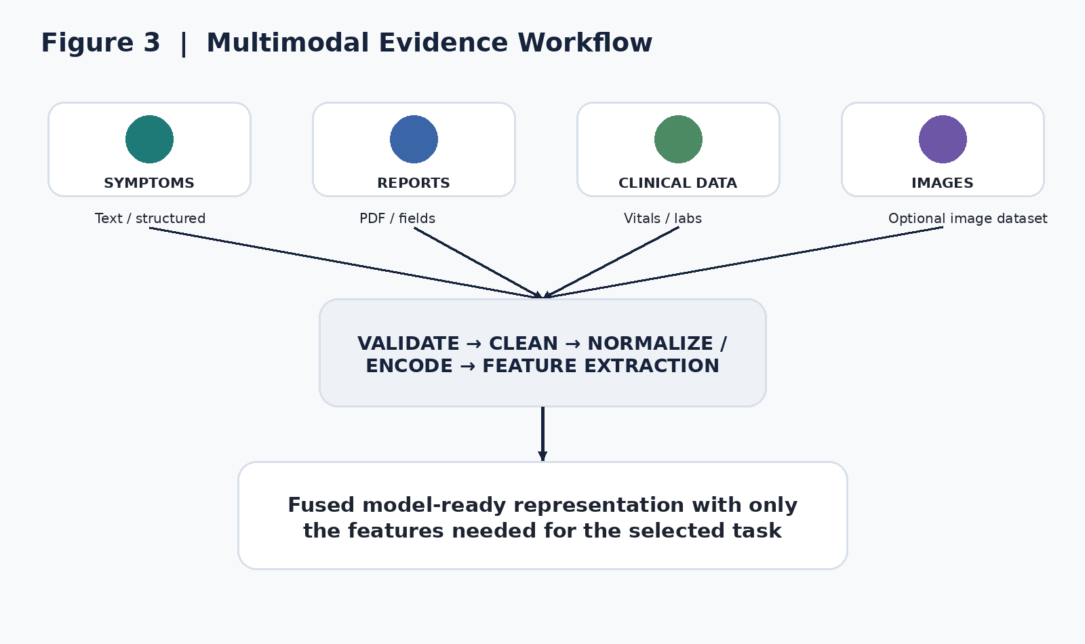
Figure 3. Multimodal evidence is converted into a compact, task-specific model representation.
The project does not require every modality in every experiment. That would add complexity without adding scientific value. Instead, the selected disease dataset defines what evidence is available. The architecture supports multiple evidence types while allowing the actual experiment to stay narrow.
- Structured branch: missing-value handling, encoding, normalization and feature selection.
- Image branch: CNN feature extraction when images are part of the benchmark.
- Fusion: combine only compatible, documented features for the selected prediction task.

6. Workflow B: Classical vs Quantum Benchmark
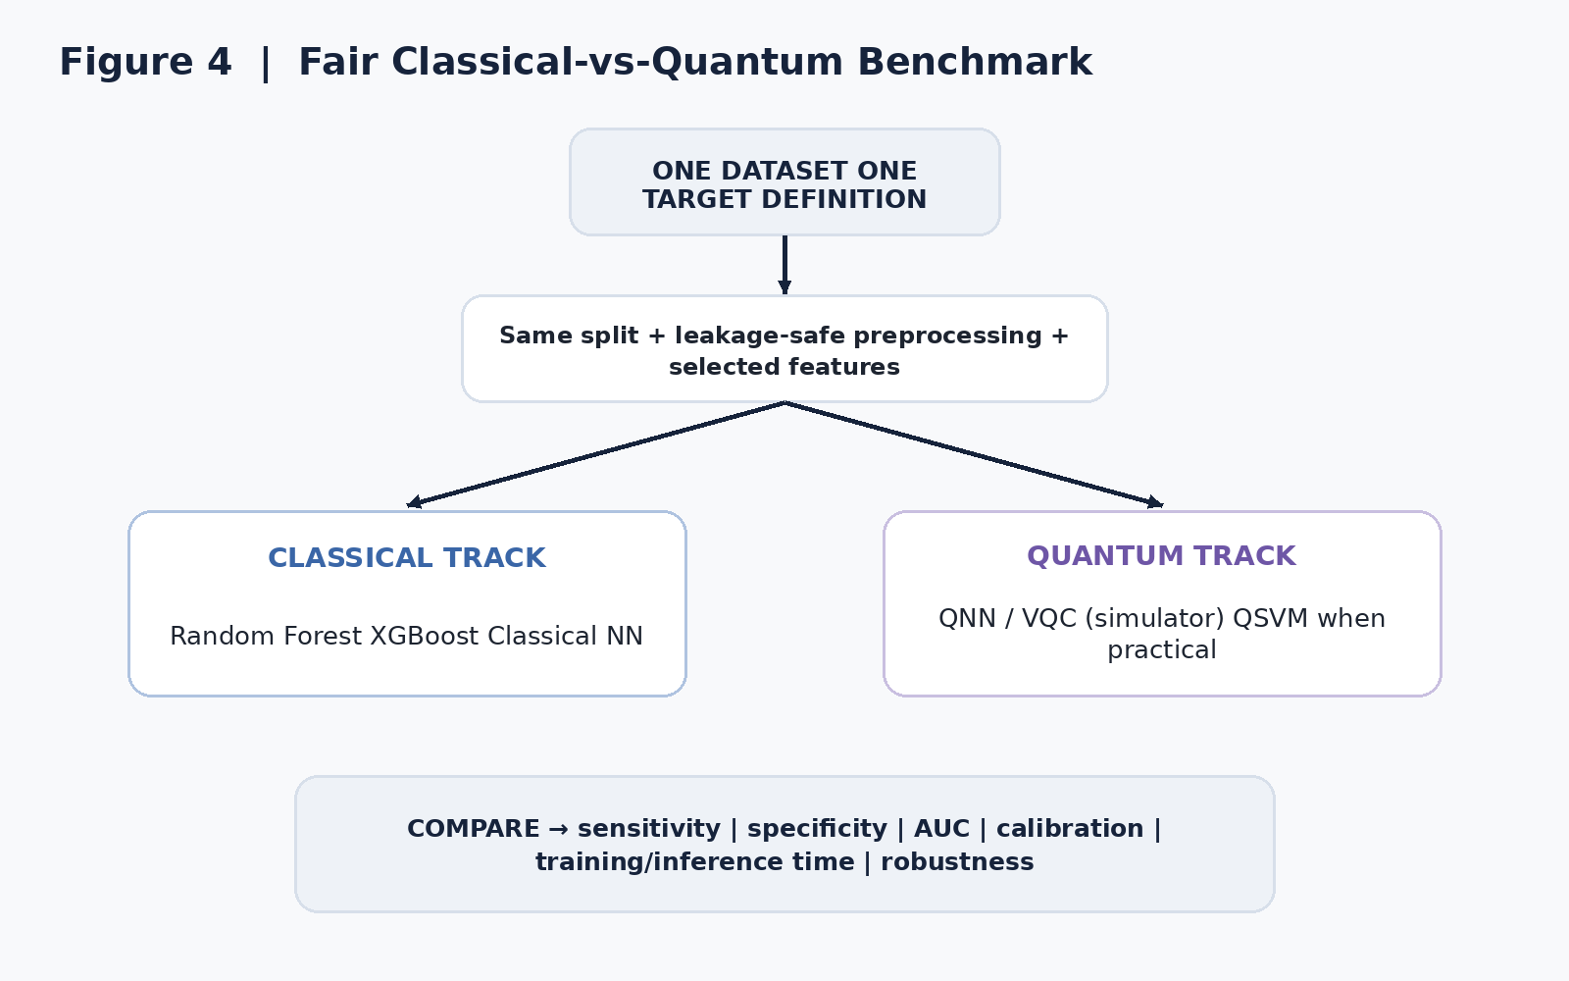

Figure 4. Fair comparison protocol used to test whether QML adds measurable value.
The word “benchmark” is doing heavy lifting here. The project should not compare a polished QNN against a weak baseline or use different data splits. Both sides should be evaluated under the same task definition and a leakage-safe preprocessing pipeline.
- Primary classical models: Random Forest and XGBoost.
- Primary quantum model: compact QNN/VQC.
- Optional secondary quantum benchmark: QSVM, only where feasible.
- Metrics: sensitivity, specificity, ROC-AUC, accuracy where appropriate, calibration, precision/F1 where useful, training time, inference time and robustness.
- Timing experiment: compare epoch/optimization time for a small Classical NN and QNN under controlled conditions.
A slower QNN is not a “failed” experiment. It is a result. The report should show the trade-off between computational cost and predictive behaviour rather than trying to manufacture a quantum victory.

7. Workflow C: Practical QNN Pipeline

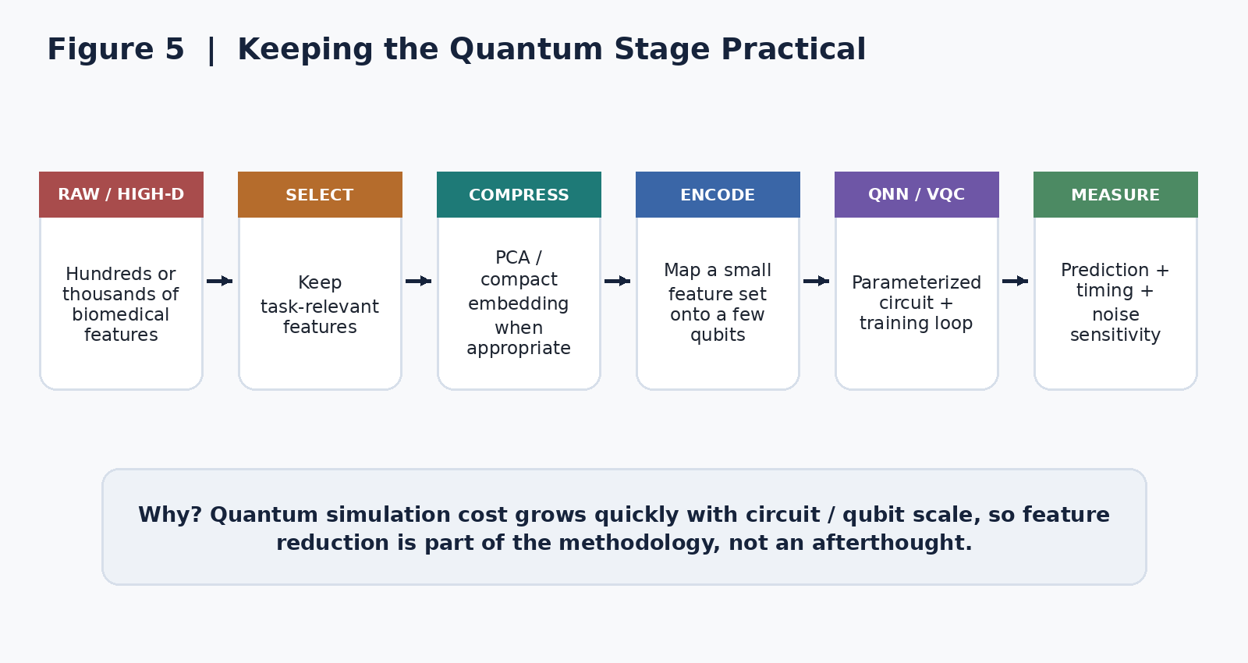
Figure 5. Feature reduction is part of the quantum methodology because simulator cost grows with circuit scale.
The quantum stage stays intentionally small. High-dimensional biomedical data is not pushed directly into a large quantum circuit. Classical feature engineering reduces the representation first, then a small number of features are encoded into a compact circuit.
- Use feature selection to preserve relevant information.
- Use PCA or another validated reduction method when justified by the dataset.
- Keep qubit count and circuit depth within a practical simulator budget.
- Record circuit configuration so the experiment is reproducible.

8. Uncertainty and Human Review
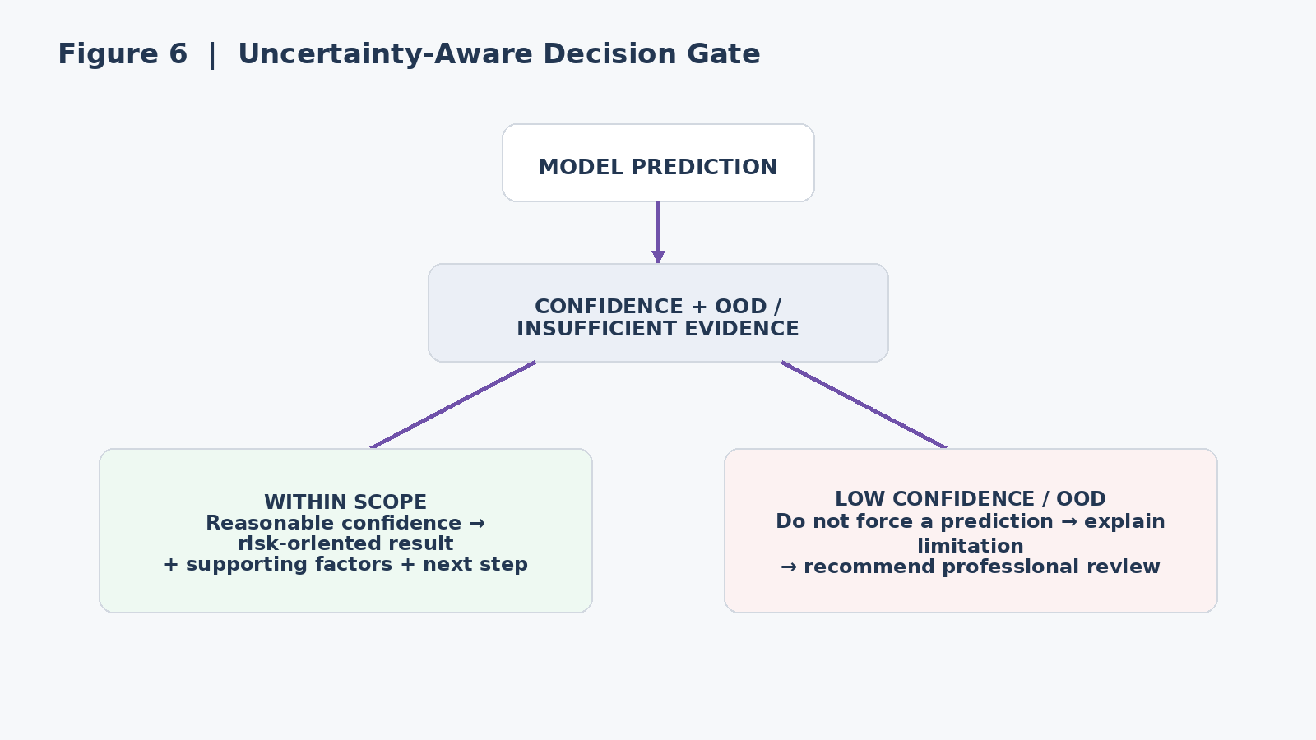
Figure 6. The uncertainty gate separates usable model output from cases that need human review.
The system should have a safe answer for “I do not know.” Confidence and OOD checks are therefore part of the output contract rather than a hidden internal metric.
- Reasonable confidence + in-distribution input -> show the risk-oriented result and supporting model factors.
- Low confidence or unfamiliar input -> show the limitation and recommend professional review.
- Medical emergency or safety-critical concern -> the product should not attempt to manage the emergency through an automated recommendation.

9. Innovation and Uniqueness
The submitted PPT establishes the right direction: multimodal evidence fusion, hybrid classical + quantum intelligence, uncertainty-aware prediction, an explainability layer, an intelligent care pathway and structured doctor handoff. It also describes the uniqueness as one continuous journey from input to analysis, risk and care, rather than a standalone symptom checker. (submitted PPT, slide 2)
For the report, that idea is made more precise: the innovation is not that we invented QNN, CNN or explainability techniques. It is the controlled workflow around them.
- Quantum Advantage Evaluation: does QML add measurable value for the chosen task?
- Prediction-to-Action flow: model output is connected to supporting factors, uncertainty and a bounded next step.
- Compact quantum pipeline: classical feature reduction is used to make QNN experimentation practical.
- Model honesty: the platform can say “uncertain” or “not enough evidence” instead of forcing a label.
- Clinician-ready handoff: the assessment inputs, model result, confidence and limitations can be organized into a structured review summary.

10. Technical Stack
The submitted PPT currently lists React.js, Python + FastAPI, Scikit-learn + XGBoost, PyTorch, PennyLane + Qiskit, QNN + VQC + QSVM, PostgreSQL and Docker. (submitted PPT, slide 3)
For the implementation, we will keep the stack focused. QNN/VQC is the primary quantum experiment; QSVM is a secondary benchmark only if it improves the research comparison without expanding the project unnecessarily.

11. Experimental Plan

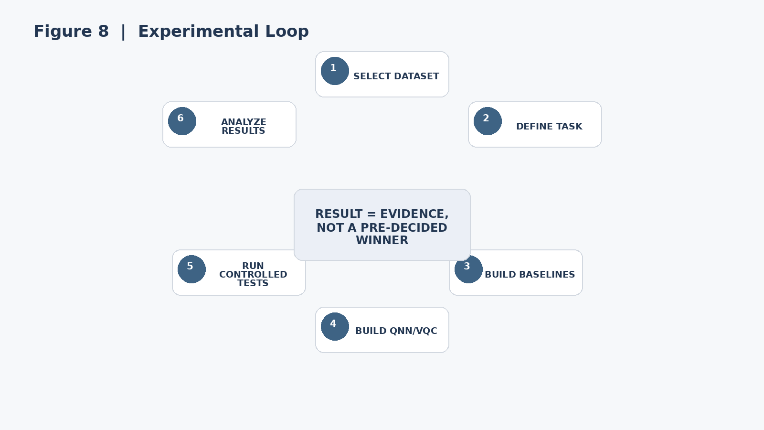
Figure 8. Experimental loop: the result is evidence, not a pre-decided winner.
Experiment | Models | Measurements | Status
Baseline | Random Forest, XGBoost | Sensitivity, specificity, AUC, calibration | To run
Neural comparison | Classical NN vs QNN | Epoch time, total time, AUC, accuracy | To run
Quantum robustness | QNN/VQC + controlled noise | Performance degradation, stability | To run
Optional QML comparison | QSVM vs QNN/VQC | Task metrics + runtime | Only if practical
Explainability layer | Model explanations | Feature importance, attribution / sensitivity | To build
Results will be inserted only after experiments are executed. The final report should include dataset version, preprocessing configuration, model configuration, random seeds where relevant, hardware used and measured results.

12. Feasibility, Risks and Mitigation
Risk | Why it matters | Mitigation
No quantum advantage | QML may not improve the chosen task. | Strong baselines + honest benchmark.
Simulation cost | Large circuits can become expensive. | Small feature budget + compact circuits.
Data leakage | Can inflate scores. | Leakage-safe split and preprocessing.
Overconfident interpretation | Could lead users to over-trust a model output. | Uncertainty gate + clear output boundary.
False reassurance | Low predicted risk could be misread. | Uncertainty gate + professional review.
Regulatory scope | Clinical software may be regulated. | Treat as SIH prototype; assess intended use before deployment.
The submitted PPT already presents feasibility, challenges and strategies in three visual cards. (submitted PPT, slide 4) The report expands those cards into engineering actions rather than repeating them as marketing points.

13. Safety, Ethics and Indian Regulatory Boundary
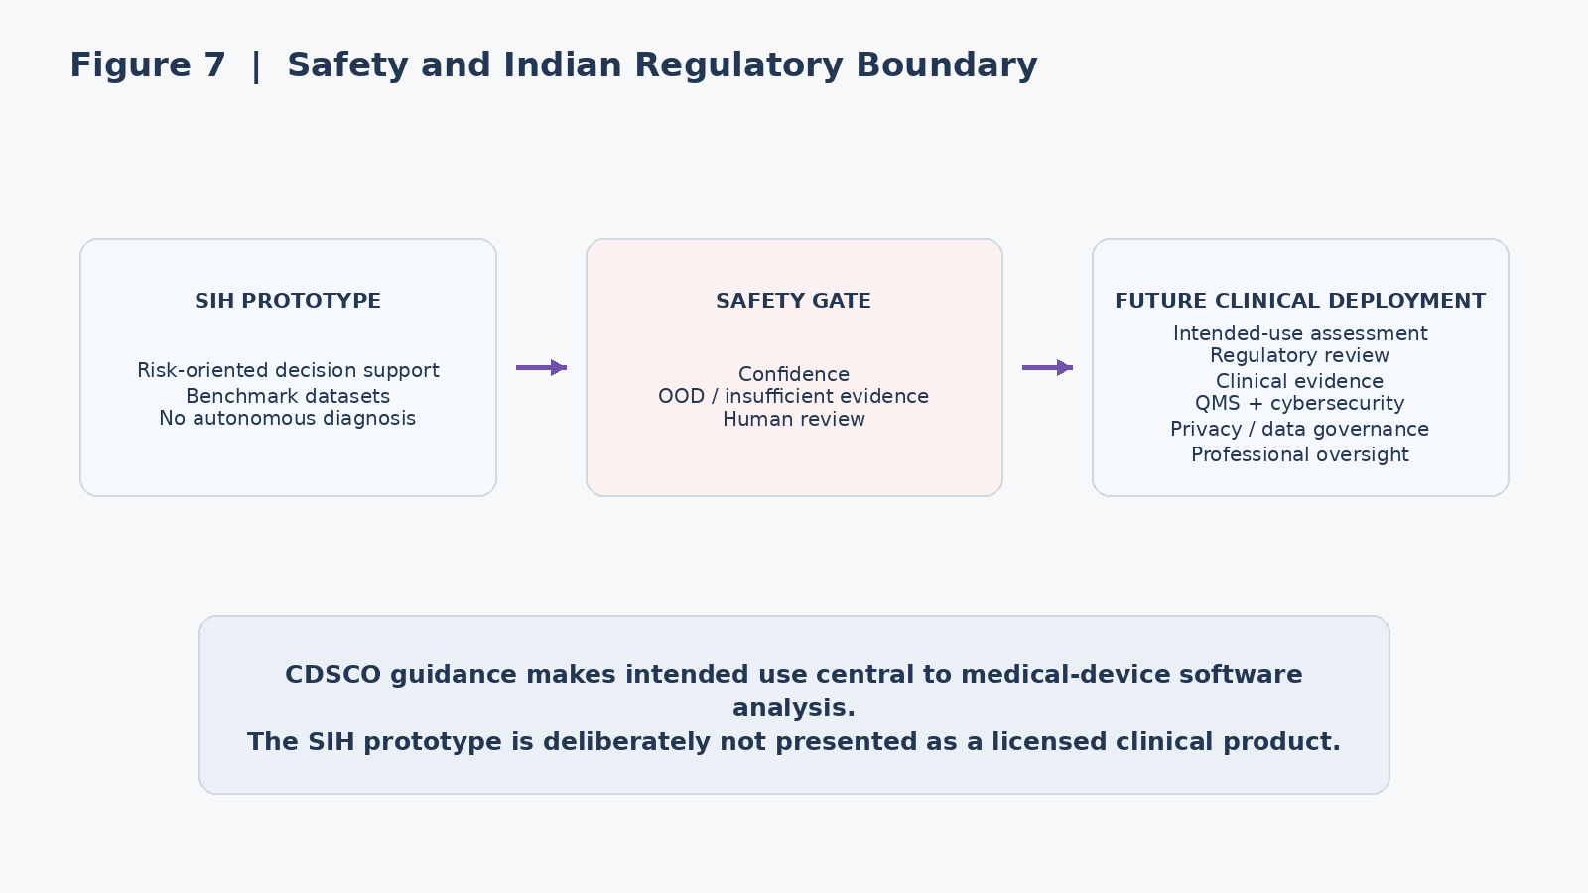
Figure 7. Safety boundary: the SIH prototype is deliberately separated from future clinical deployment.

Current CDSCO material states that medical devices in India are regulated under the Drugs & Cosmetics Act, 1940 and the Medical Devices Rules, 2017. CDSCO’s 2026 Guidance Document on Medical Device Software explains that software intended for a medical purpose can fall within the medical-device framework and that intended use is central to the analysis. The guidance also discusses clinical evidence, quality-management systems, risk classification, cybersecurity, regulatory submission and post-market requirements. [R2]
This matters for our wording. Calling the prototype a “risk assessment platform” does not by itself guarantee that a future commercial product would be outside regulation. If the software is eventually intended for a medical purpose, the intended-use statement and regulatory pathway must be assessed before clinical deployment.
- No prescription or dosage recommendation.
- No claim of autonomous diagnosis.
- No claim of clinical validation from benchmark data alone.
- Use de-identified/public datasets for the SIH prototype whenever possible.
- Do not claim ABDM integration unless standards, APIs and authorisation are actually implemented.
- If telemedicine is added later, use the applicable Indian telemedicine requirements and professional oversight.
WHO guidance also stresses human autonomy, safety, transparency/explainability, accountability, inclusion and sustained governance for AI in health. [R5]

14. Implementation Roadmap

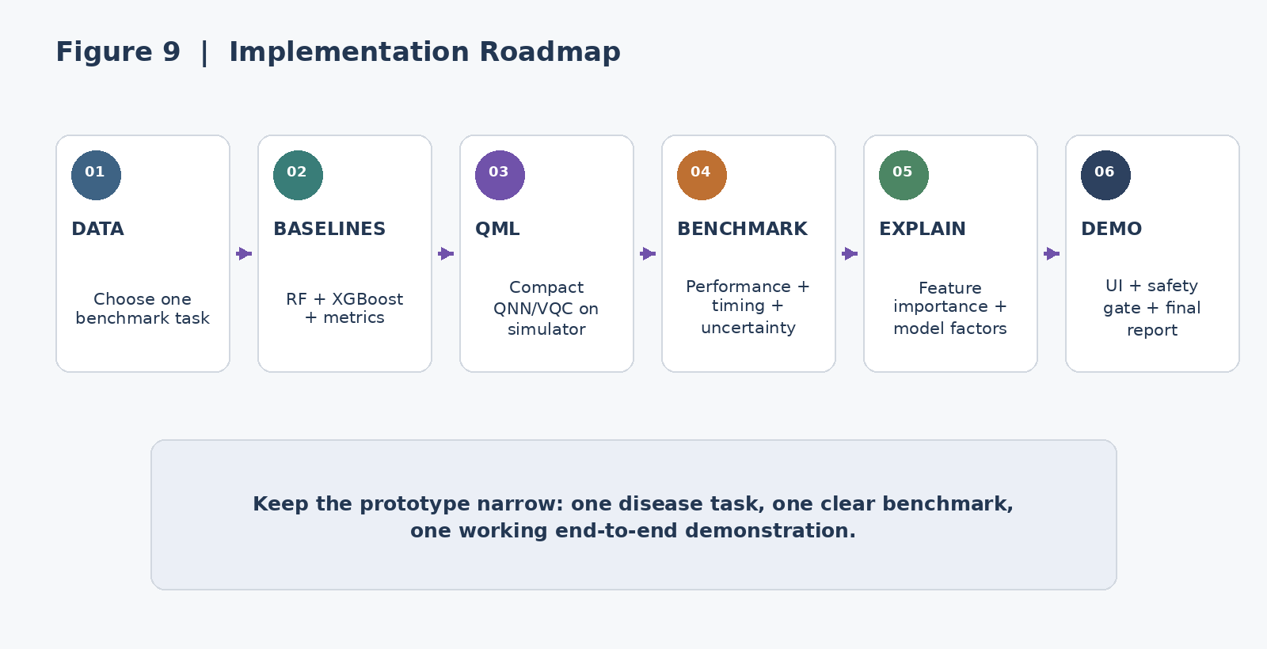
Figure 9. Narrow implementation roadmap for the SIH prototype.

15. Expected Impact
Target audience | Expected value
Patients / users | A clearer view of a model-generated risk signal, its evidence and uncertainty, without pretending that the system has made a diagnosis.
Healthcare professionals | A structured evidence summary that makes model inputs and uncertainty easier to review.
Researchers | A reproducible environment for comparing classical ML and QML on the same biomedical task.

The submitted PPT identifies patients, healthcare professionals, hospitals/clinics, researchers and underserved regions as target audiences, and lists faster analysis, decision support, data use, research and accessibility as benefits. (submitted PPT, slide 5) In the report we phrase these as expected design benefits, not clinical outcomes that have already been proven.

16. Limitations and Future Scope
- Simulator-based QML is not equivalent to a fault-tolerant quantum computer.
- A small qubit budget limits the dimensionality of the direct quantum representation.
- Benchmark datasets do not establish clinical effectiveness or population-level safety.
- Explainability has limits: model-based explanations describe model behaviour; they do not prove causality or clinical correctness.
- Future clinical deployment would require dedicated clinical evidence, quality, safety, security, privacy and regulatory work.

17.ADDITIONAL FEATURE- Video Consultation + Speech-to-Text MOM
This addendum adds a video consultation and speech-to-text Minutes of Meeting (MOM) feature to the existing platform without changing the original research workflow, model methodology, benchmark protocol, flowcharts, or conclusions.
A. Video Consultation Module
The platform can include a secure in-app video consultation module that allows a user and an authorised healthcare professional to conduct a live consultation. The consultation sits after the model-generated assessment and human-review stage, so the communication layer does not replace the existing ML/QML pipeline.
- Live video and audio consultation between the user and authorised healthcare professional.
- Consultation session creation with a unique session identifier.
- The existing risk-oriented result, supporting factors, confidence/uncertainty and limitations can be made available to the authorised reviewer during the consultation.
- The clinician/reviewer remains responsible for interpreting the model output and conducting the consultation.
- The feature is designed as a communication and documentation layer, not as an autonomous diagnosis or emergency-management mechanism.
B. Speech-to-Text and MOM Generation
During the video consultation, the speech-to-text component converts the spoken conversation into a timestamped transcript. A MOM layer then organises the transcript into a structured consultation summary. The generated MOM is a documentation aid and remains subject to human review.
- Speech-to-text conversion of the consultation audio into a readable transcript.
- Speaker-aware or speaker-labelled transcript where the implementation supports reliable speaker separation.
- Extraction of key discussion points, reported symptoms or concerns, observations, questions and agreed next steps from the transcript.
- Generation of a structured MOM containing consultation date/time, participants, key discussion points, decisions or observations, and follow-up actions.
- Human review and editing before the MOM is treated as the final consultation record.
- The system should clearly distinguish machine-generated text from information directly entered or confirmed by the healthcare professional.
C. New Feature Workflow
01  START  CONSULTATION | 02  VIDEO + AUDIO | 03  SPEECH → TEXT | 04  MOM ENGINE | 05  HUMAN REVIEW | 06  STRUCTURED MOM
Create authorised  video session | Live patient / reviewer  conversation | Generate transcript  with timestamps | Organise discussion,  points and actions | Reviewer verifies,  edits and confirms | Save/share the approved  consultation summary
START → VIDEO + AUDIO → SPEECH-TO-TEXT → MOM → HUMAN REVIEW → APPROVED RECORD
Figure A. Video consultation and speech-to-text MOM workflow.
D. Integration with the Existing Platform
The new feature extends the existing architecture rather than replacing any component. The current React.js / React Native frontend can host the consultation interface, while the Python + FastAPI backend can orchestrate consultation sessions, transcription and MOM generation. PostgreSQL can store controlled session metadata and approved MOM records. The existing ML/QML pipeline remains unchanged.
Existing Layer | Added Capability | Purpose
Frontend | Video consultation + transcript/MOM view | User and reviewer interaction
Backend | Consultation/session APIs | Session orchestration and access control
Speech Layer | Speech-to-text | Convert consultation audio into text
MOM Layer | Structured summary generation | Create reviewable consultation notes
Database | Session metadata + approved MOM | Controlled storage of records
ML/QML | No methodology change | Existing risk assessment remains intact
E. Connection to the Existing Clinician-Ready Handoff
The feature directly extends the report's existing clinician-ready handoff concept. The assessment inputs, model result, confidence and limitations can be available as review context, while the consultation produces a separate human-reviewed MOM. This creates a continuous path from model output to professional discussion and documented follow-up without changing the existing prediction methodology.
F. Privacy, Safety and Human Review
- Video, audio, transcript and MOM data should be treated as sensitive information and protected with appropriate access controls.
- Recording should be explicitly controlled and should require appropriate user consent where applicable.
- The system should provide a clear indication when speech-to-text or MOM content is machine-generated.
- The healthcare professional should review and correct the transcript/MOM before it is considered an approved record.
- The feature should not be presented as a substitute for professional medical judgement.
- Emergency or safety-critical situations should continue to follow the existing safety boundary described in the report.
G. Updated Feature-Level Value
The added module gives the platform a practical communication and documentation layer around the existing research workflow. The core contribution remains the controlled comparison of classical ML and simulator-based QML for early disease-risk assessment. The video consultation and speech-to-text MOM capability provides a structured way to discuss the model output with a healthcare professional and preserve the reviewed discussion as a consultation summary.

18. References
[R1] SIH26139 official problem statement
https://sih2026.vuce.in/ps/SIH26139
[R2] CDSCO, Medical Device & Diagnostics / MDR-2017 information
https://www.cdsco.gov.in/opencms/opencms/en/Medical-Device-Diagnostics/Medical-Device-Diagnostics/
[R3] MeitY, Digital Personal Data Protection Rules, 2025
https://www.meity.gov.in/documents/act-and-policies/digital-personal-data-protection-rules-2025-gDOxUjMtQWa?pageTitle=Digital-Personal-Data-Protection-Rules-2025
[R4] WHO, Ethics and Governance of Artificial Intelligence for Health
https://www.who.int/publications/i/item/9789240029200
[R5] Nature npj Digital Medicine, Systematic Review of Quantum Machine Learning for Digital Health
https://www.nature.com/articles/s41746-025-01597-z
[R6] A Systematic Review of Quantum Machine Learning for Digital Health - https://www.nature.com/articles/s41746-025-01597-z?
[R7] Power of Data in Quantum Machine Learning
https://www.nature.com/articles/s41467-021-22539-9

[R8] Challenges and Opportunities in Quantum Machine Learning
https://www.nature.com/articles/s43588-022-00311-3

[R9] A Systematic Literature Review of Quantum Machine Learning for Medical: Trends, Datasets, Topics, and Methods
https://www.sciencedirect.com/science/article/pii/S2666307426000112

[R10] Data Reference Link –
https://www.nhsinform.scot/illnesses-and-conditions/a-to-z

